Chattisham & Hintlesham Parish Council

**MINUTES OF THE MEETING OF CHATTISHAM AND HINTLESHAM PARISH COUNCIL HELD AT THE COMMUNITY HALL MEETING ROOM ON THURSDAY 13th October 2016**

**----------------------------------------------------**

**PRESENT:**

**Councillors**: Stephanie Coupland (chair), John Whyman, Jamie Bostock, Ben Cox, David Marsh, Diane Chase, Frances Self, Debbie Archer, Stuart Kellett, Chris Leney

**Parish Clerk**: Samantha Barber.

**District Councillors**: Barry Gasper, Nick Ridley

**County Councillor**: Dave Busby

**Members of the Public:** There were 6 members of the public present.

Presentation made by Adrian Waller about Defibrillators for the village

The council welcomed Adrian Waller from Zoll Medical UK Ltd to explain about defibrillators. Adrian spoke about his and the companies background. Devices would require being placed in a locked cabinet, the location would be logged with the emergency services. The code is then given when 999 is rung. Three devices covering Hintlesham and Chattisham would be considered sensible. FDA approved devices are considered the best in terms of clinical excellence. No electricity is required and nor is a rechargeable battery. The cabinet needs electricity and siting the defibrillators in telephone boxes would enable the electric supply to be readily taped into. AED’s need regularly checking and someone needs to look after them and take responsibility. Ongoing maintenance costs need to be considered. Batteries and Electrodes need to be replaced every five years at a cost of £200.

Resident Colin Tee had spent some time researching the subject – The British Heart Foundation will support the purchase of an AED however currently funding is not available although this is subject to change . The East Anglian Ambulance Service is supplying AED’s for £1945 with training.

A Zoll Medical UK Ltd cabinet and AED will cost £1500. Adrian is happy to give training to the village in CPR.

Adrian was thanked for taking his time to explain all about AED’s and providing the Parish Council with much information to consider.

The main Parish Council meeting was then opened

1. **Apologies for Absence**

Apologies for absence had been received from Peter Eaton and Ian Bryce.

1. **To approve the minutes of the meeting dated 8th September 2016**

The minutes had been circulated to all councillors and were proposed as a true record by Jamie Bostock and seconded by John Whyman the minutes were duly signed by Stephanie Coupland

1. **Declaration of Interest of any item on the Agenda**

The interest book was signed by Jamie Bostock and Chris Leney in relation to the planning item.

1. **Matters arising from the Minutes dated 8th September 2016**

Speedwatch – The forms from the school have yet to be returned for the speedwatch volunteers

Speedcheck – An e-mail has been received from John Simpson at Suffolk County Council Highways regarding the speedcheck on the A1071 and this now appears to be taking place as engineers have installed a box to capture speed along George Street.

BAPTC – Another meeting of the Alliance is due to take place soon.

1. **Adjournment for Reports from County and District Councillors, Comments from Residents**

Dave Busby reported that he had a meeting with John Simpson from Highways who had taken all points from the parish council on-board with some progress on each item hopefully soon. This includes the yellow lines outside the school, speed and the quality of road repairs and resurfacing.

Devolution – Dave Busby had attended a training session regarding devolution.

Dave had also had training on being a dementia friend and reported it is possible for the village to also have training.

Dave had spoken to Jane Storey SCC who is willing to come and speak to the parish council in regard to Broadband and just needs to be invited to a meeting.

A cheque is on its way from the Locality Budget for the bowls club

John Whyman asked some questions about overhead broadband and the possibility of grants for the community. Dave was not aware of any grants but mentioned it may be worth asking Jane Storey about.

District Council – Interviews are to take place imminently for the new Chief Executive. The vote has been taken for Babergh and Mid Suffolk to move to Endeavour House in Ipswich with a moving date of April 2017 a possibility. ‘Spokes’ are being considered in Hadleigh, Stowmarket and Sudbury. Parking and commuting into Ipswich is an issue with many of the employees. Devolution remains a hot topic of conversation. Suffolk may well devolve on its own with Norfolk pulling out. A decision at District Council level needs to be made by the end November on whether to support Suffolk seeking devolution alone. The possible options for both the Hadleigh and Needham Market offices are being considered with both selling and renting out the buildings an option.

Residents – A resident had spoken to the Suffolk County Council workers when they were installing the speed device on the pole which will capture the speed of a vehicle and number of vehicles. A strip across the road could not be used as the road would have to be closed to install the strip, this is unfortunate as the size of the vehicle cannot be recorded.

1. **Muga Update -**

John had sent an e-mail and a copy of this is included at the end of these minutes which explains where the project currently stands.

A pre-application meeting with Babergh planning was considered a sensible idea to establish whether planning is a possibility especially in relation to the lighting.

The Community Council will consider the proposal and make a decision regarding support at their next meeting.

John Whyman on behalf the MUGA Group proposed that a pre-application meeting at Babergh be sought, this was seconded by Jamie Bostock. A vote was taken with all in favour.

1. **Defibrillator –**

The time taken to get to a casualty was considered a concern. There was a long discussion regarding the financing, siting and various issues. It was considered that the Community Hall would be the best place for a defibrillator to be sited. Training for CPR was considered a good idea for the village. A proposal was made to look into grants and information from the British Heart Foundation and any other possibilities for funding, the clerk will undertake and report back.

1. **SALC Survey of Issues**

The clerk will complete the survey with the Parish Council’s recent recorded issues such as Broadband speeds and Highways problems.

1. **Planning –**

B/16/01045 – The Pony Paddock, Duke Street, Hintlesham

Erection of five dwellings

Comments were made about the settlement pattern in Duke Street which is currently linear and this application will alter that pattern and is contrary to CS11

In terms of infrastructure, the school cannot support any more admissions and it was noted that although referred to in the application there is not a shop in the village.

A proposal was made that the council object to the application on the grounds that it is against the existing linear development pattern in Duke Street , no case has been given for local need and the school does not have the capacity to deal with the expected rise in numbers. The application also does not consider the cumulative impact of the existing fifteen dwellings which have planning permission in Duke Street but which have yet to be built

A vote was taken and the decision to object accepted with four in favour and four abstaining. Two councillors did not take part in the vote.

Building works at Sunnyside in Chattisham has been referred to Planning Enforcement at Babergh District Council and we await their response.

1. **Reports from Parish Councillors.**

PublicTransport – Bus fares have risen for the first time in a number of years

1. **Expenditure**

The following cheques were approved and signed

Chq Expense Payee Amount

916 Clerk Salary S Barber £106.25

917 Grass Cutting Vertas £334.04

918 Data Protection ICO £35.00

1. **Correspondence**

No correspondence items had been received.

1. **Any Other Business/Items for Next Agenda**

A member of the road safety team from the school arrived to give a short report about the portable VAS signs which they are keen to make an application for. Debbie Archer kindly agreed to help with the application process. The PTA have offered support in terms of funding as has Cllr David Busby via his Locality Budget

**Meeting closed at 9.10pm**

Feasibility Report

Multi Use Games Area

MUGA Task Group Report to Parish & Community Councils

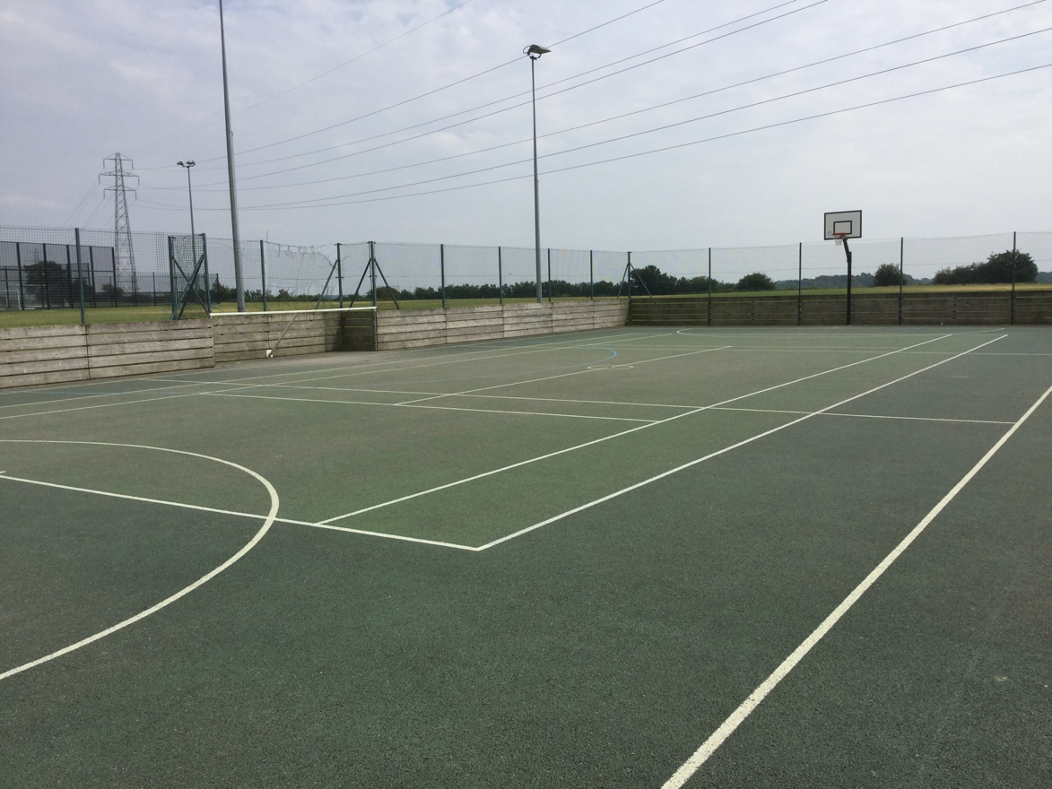

# Introduction

The parish council discussed the potential use of monies held in trust by Babergh District Council following development contributions to the community. These funds are held by BDC under section 106 Planning Obligation, Recreation Contribution (Policy HS32) and it is recognised these monies may, potentially, be returned to developer donors if the funds are not used for their designated purpose. The parish council requested, as the responsible body, the Hintlesham & Chattisham Community Council undertake a survey of residents, throughout the communities, to establish a preference of project between 5 different options. This process was undertaken throughout September 2015 with a questionnaire circulated via the ‘Village Link’. The parish council were advised by the CC that 82 replies had been received. The most popular response was for monies to be deployed to resurface the CH car park. Following discussions with BDC (Nick Elliot) this option was rejected as be a suitable use for S106 monies. During the PC meeting held on 12th November 2015, residents raised the desire to consider the creation of a Multi Use Games Area (MUGA). It was agreed at this meeting between CC Chair, Eileen Damant and the PC to create a joint PC/CC Working Party Task Group to undertake an investigation into the feasibility of such a project, looking at location, capital cost of construction and operational management.

Andrew Bryce agreed to take on the initial responsibility to consider the project feasibility.

* **Community Research Survey –** AB coordinated details into the Village Link asking residents to undertake an online survey into whether they considered the community would benefit from having access to an ‘all weather’ sports area. In summary, 81% of residents who responded were in favour, 5% were not in favour & 14% undecided.
* **Follow Up Basic Research -** As a result of the positive response to the survey, AB undertook some basic analysis of anecdotal capital costing, preliminary discussion with BDC in relation to potential acceptability for S106 funding and additional grant funding.
* **Location Survey –** A basic survey was undertaken of the Hintlesham playing field to establish how a MUGA might be located in relation to the existing football pitch and give consideration to access to the CH & changing rooms (playing field hut). Three potential options were established A,B&C.
* **Joint PC/CC MUGA Task Group –** The PC & CC established the task group in May 2016. Andrew Bryce asked to take a ‘back seat’ on the project due to increasing work commitments, but was happy to continue to support the project from the ‘back row’. The group asked Jamie Bostock & John Whyman to take a lead role managing the group.
* **Contractor Meetings –** During the summer JW, JB & DA asked contractors, with a proven track record in this field, to provide initial indicative costings for MUGA options, giving consideration to surface type, fencing & lighting. Contractors, thus far considered, are Cambridge Courts, Doe Sport Ltd & Playdale. Both Cambridge Courts & Doe Sport Ltd have visited the site & given constructive advice on various site issues and Games Area orientation.
* **Operational Games Area Research –** The task group visited Bealings village & met with Jenny Shaw (Bealings MUGA Coordinator) to discuss their experiences of construction they undertook 8 years ago, the operational access & charging structure and their general experiences of operational activity.
* **Public Consultation –** The task group, after looking closely at the various construction, location and operational issues, considered that there should be a further opportunity for the communities to make representations on the potential project. It was decided it would be opportune to coordinate this date with the village garden show on the 10th September. A display of information was provided in the playing field hut from 10.00am until 12.30pm, thereafter, in the Community Hall meeting room. It was agreed the task group should have this event ‘manned’ to take on board & record comments and positive/negative responses from residents. After analysis of the recorded responses from residents who visited the event. There were 24 ‘suggestions/thoughts’ on the project. From a ‘support/not support/undecided’ survey undertaken. Of those who gave a view, 75% expressed support, 12.5% expressed not supportive & 12.5% undecided.
* **Review Meeting –** The task group were keen to expand the number of people within the group to get the best possible breadth of opinion within the community. Our final meeting was held on the 10th October in the Community Hall meeting room. The group analytically examined all the information thus far held. We considered all the written and aural responses to the project that had been recorded. A paper considered by the group looked at anecdotal operational costs of operation. We considered it to be fundamentally important to ensure the group had a true and properly agreed mandate from the community to progress the project further and make a recommendation to the PC & CC. The group met for 2 hours considering these points and, at the end of their discussion voted on 3 proposals. Proposal 1, was to recommend to the PC & CC to ‘scrap’ the project. Proposal 2, was to undertake further work to more completely validate the project with the community. Proposal 3, was to recommend to the PC & CC to proceed to obtain Planning consent for the full development, which would be a 37m x 18m, AstroTurf surfaced, floodlit Area. Furthermore request funding from the Community Council for the planning application and site surveys. The group, consisting of 10 members, voted unanimously for proposal 3.
* **Stakeholder Engagement –** One of the principle questions from many residents throughout the investigation process has been the potential use of the Games Area by the school. We have received a letter from Roy Midgeley, the school PE Coordinator, confirming their full support to help & use the facility both during ‘school hours’ and extra-curricula times in the evenings and holidays. They have confirmed adequate pupil/staff ratios exist to ensure pupils can be safely escorted from the school to the potential MUGA site. Needless to say this gives a significant boost to the project, both from a ‘social benefit’ perspective, but also for potential revenue generating clubs and a wider local market catchment which would assist and support its sustainability.

## Recommendation

The group has closely analysed and challenged its own findings both in terms of the ‘needs assessment’, its potential financial sustainability (separate fact sheet attached), the capital financial challenge, but most importantly, the democratic mandate which is vital to the projects success. Under no circumstances is their an appetite for a ‘white elephant’ and potential financial drain on the community. It is for the forgoing reasons the MUGA Task Group recommend to the Parish and Community Councils that the project enters, 2 further phases. The next phase, which is critical to the overall sustainability of the project is to apply to BDC for outline planning consent for the Multi Use Games Area (Astro-turf basis), fully fenced and with floodlighting. All our anecdotal financial information indicates a unit with lighting extends its operational availability into significant revenue earning phases of the day and yearly seasons to allow it to provide ‘low or no cost’ use to the indigenous community. Needless to say this throws up the ‘planning challenge’ which has to be overcome or not through the normal democratic mechanism of the planning application. We feel this is a crucial part of our recommendation as to proceed without a lighting facility would likely render the MUGA a loss leading Community asset which would be, we anticipate, unacceptable to the Community Council as potential operator. Funding for the application and any supporting surveys etc could be met by the monies held by the CC which have been donated and targeted at the creation of the MUGA facility. We would, therefore, commend our recommendation to the Parish and Community councils for there consideration and response. Should the joint councils accept our recommendation we would envisage moving to the next phase.

